Welcome to Kumla, Sweden and the World Cup in Boogie Woogie
- Last day of entry, March 16, 2024
- Starting fee, €25/dancer. Dansklubben Dancemania
Registration and payment at the arena Vastra Drottninggatan 43
Card or cash in the exact amount 692 33 Kumla
The Competition Arena: Villagatan 38, 692 35 Kumla. If you come by car, the carpark is available from Viagatan.
- For your travel arrangements, we recommend flying to Stockholm Arlanda Airport, where it is easy to catch a connecting train to Kumla. Alternatives are Gothenburg Landvetter Airport, Karlstad Airport or Västerås Airport.
- Kumla Hotel: https://kumlahotel.se/, approx 100 m from Kumla trainstation and approx 700 m from Competition Arena
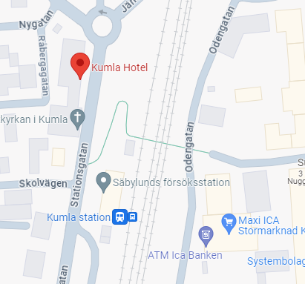
- Hotell Stinsen, Hallsberg: https://hotellstinsen.com/, approx 100 m from Hallsberg trainstation, transport to and from Competition Arena will be provided by Dansklubben Dancemania.
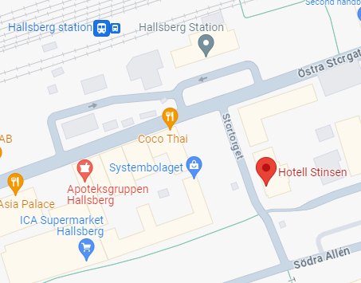
- The Competition Arena: Villagatan 38, 692 35 Kumla. If you come by car, the carpark is available from Viagatan.
The Competition Arena, Kumlahallen:
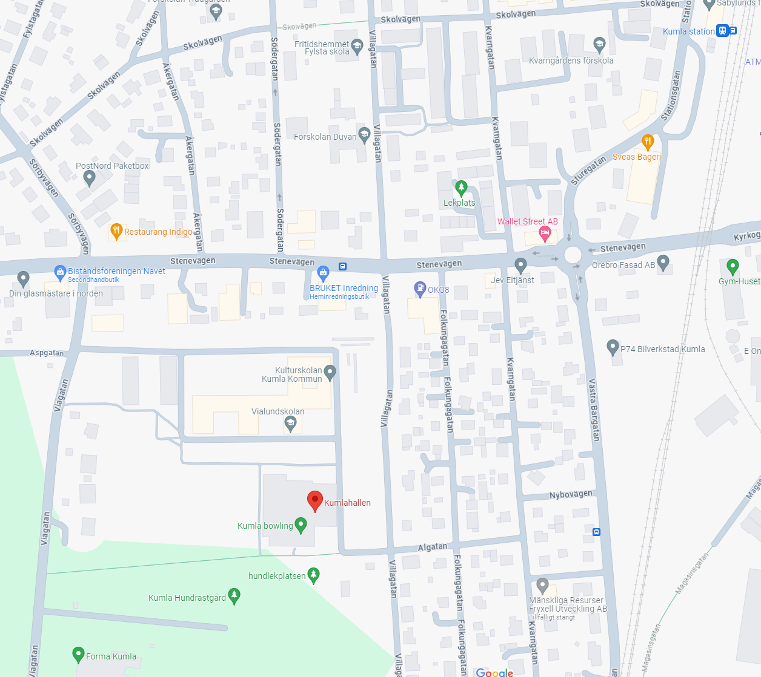
P

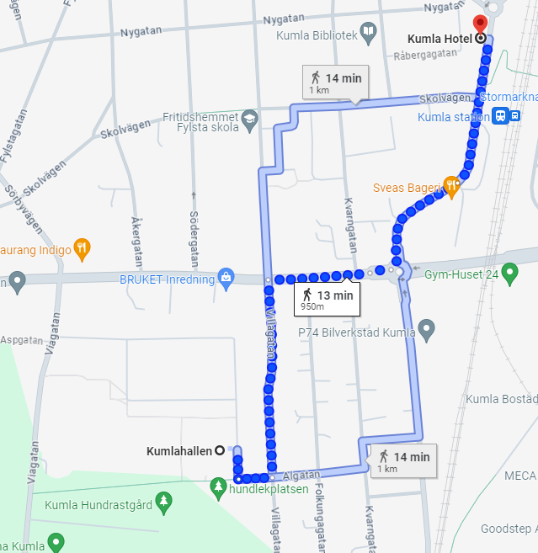

Welcome to Kumla, in the heart of Sweden
https://visitkumla.se/
Kumla is the town on the Närke plain, just outside the city of Örebro. A little oasis in the countryside and yet only 9 minutes by train to the buzz of the city.
A lovely town centre around Kumla square with shops, restaurants, cosy cafés, grocery stores and other services such as hairdressers and a shoemaker. The fact that there is a shoemaker in town is perhaps not so strange as the town has a history around the shoe industry. Today, with two of the country´s leading brands of shoe, but back then, with over 130 shoemakers in town.
Kumla is also known as being arty, most literally. With a wide offering of art and culture we consider ourselves as “the Art Capital of Närke”, the landscape in Sweden where Kumla is located. Art på Hög (Art at the Top), with its colourful history, extensive views and famous art exhibition – really should not be missed! And don’t forget Örsta Art Gallery or Konsthallen Art Gallery in our beautiful library. For that matter don’t miss a stroll around town. You will be amazed at how much art you will find there. 24/7. Always open to enjoy.
Kumla also has a vast adventure pool, a Town Park for fun and fantasy, a prominent speedway team, an 18-hole golf course in a beautiful setting, and incredibly close to the slalom slopes, down-hill runs, hiking trails and bathing spots. And people of course. The home town of both racing star Marcus Ericsson and the author Håkan Nesser.
IBAN SE90 8000 0845 2570 4370 4308
BIC SWEDSESS

