WDSF BREAKING JUDGES CONGRESS 2023

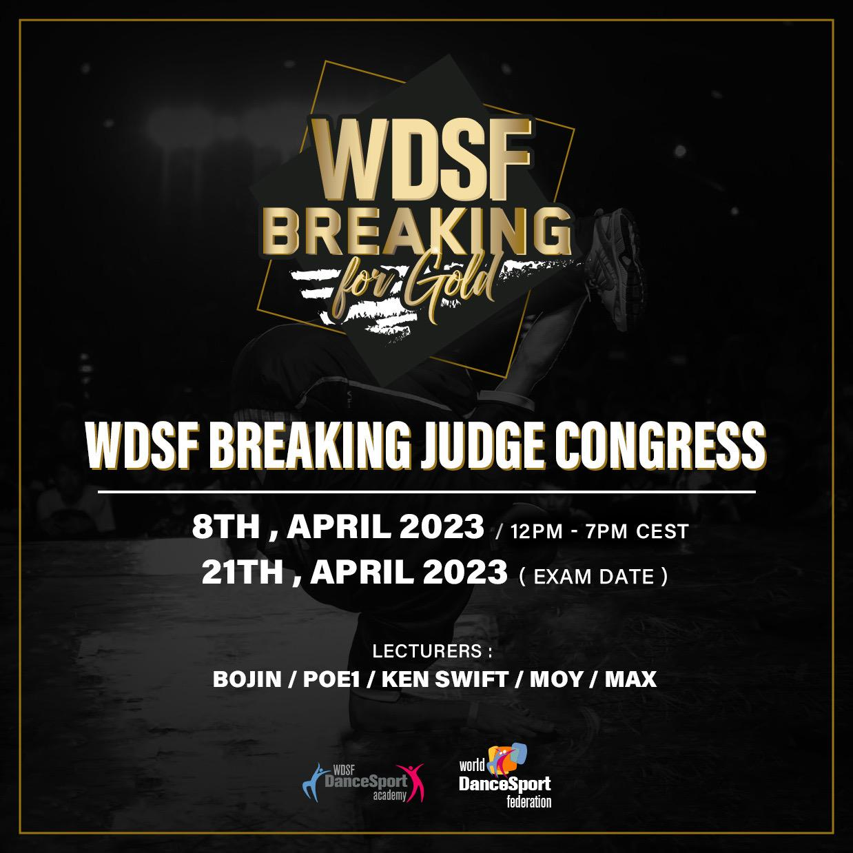

The Congress will be held online on:

- April 8th, 2023, from 12:00 to 19:00 CEST
  - 18:00 to 01:00 Beijing, Hong Kong, Manila, Singapore
  - 06:00 to 13:00 Eastern Daylight Time
  - 03:00 to 10:00 Pacific Time

The Congress will include topics on education and training of the new WDSF Breaking Judging System.

The lecturers will be BOJIN (TPE), MAX (POR), KEN SWIFT (USA), MOY (USA), POE1 (USA) and Experts from the WDSF Judging System IT structure.

WDSF BREAKING JUDGING SYSTEM

The new WDSF Breaking Judging System provides organizers of future WDSF Breaking events with an alternative, approved Judging System.

This system shall be used for WDSF Breaking events of all grades as soon as it is released. Therefore, it is important for all License holders to be part of the Congress and to familiarize themselves with the new Judging System. Only judges who have attended the WDSF Breaking Judges Congress and who have passed the exam on the new WDSF Breaking Judging System can be nominated to officiate in any WDSF Breaking event with the Judging System in use.

This development is in line with the WDSF’s mission to continuously improve the WDSF Breaking Judging System for the benefit of our athletes.

ELIGIBLE CANDIDATES

The Congress is open to:
- WDSF Breaking Judges with a valid and existing TRIVIUM /Judging License A
- (free of charge / no mandatory exam)
- WDSF Breaking Judges with a valid and existing THREE FOLD / Judging License B
- (see congress fee and exam announcement below)
- New applicants to a WDSF Breaking Judging License
- (see congress fee and exam announcement below)

CONGRESS FEE

The Congress fee is CHF 100/- person. The fee includes exam participation and one free re-test.

EXAM LEVELS

The Exams will be held on April 21st, 2023

Exam 1: Candidates of the WDSF Breaking Judges License B:
- New Applicants OR
- Holders of a valid and existing* Judging License B with an exam result of less than 70% OR
- Applicants who did not pass the previous THREE FOLD Exam

Exam 2: Candidates of the WDSF Breaking Judging License A
- Holders of a valid and existing* Judging License B with previous exam result of 70% or better only

*Valid and existing license means the respective license must have already been issued and valid at the time of Congress, and the annual license fee must have been paid.

Further details on the exams will be announced during the Congress.

DEADLINES

The deadlines for:
- Registration of new applicants for the WDSF Breaking Judge License: March 25th, 23:59 GMT
- Registration and payment for the Congress: April 4th, 23:59 GMT

Candidates may only register for this congress by registering through their RLS national administrators.

Should you have any further questions, please do not hesitate to contact the WDSF Academy (academy@wdsf.org).

APPLICATION PROCEDURE FOR A NEW WDSF JUDGES LICENCE (BREAKING)
Step 1:
The National Member Body RLS Administrator submits an online application ensuring that the applicant meets the following criteria:
  - The applicant must be over 21 years of age
  - The applicant must have retired from elite level competitions (e.g. WDSF Breaking Competitions, etc.)
  - The applicant is physically fit (includes vision and hearing) to perform the duties of a WDSF Judge
  - The applicant must have the Citizenship or Permanent Resident Permit of the country of the National Member Body he/she represents.
Step 2:
Once accepted, the applicant will receive an email notification to provide additional information for verification purposes, including contact details and a copy of the passport.
Step 3:
Once approved by the WDSF Academy, the applicant can then sign up for a congress, the final examination and pay the Congress fee CHF100.
Step 4:
Applicants that have passed the examination will then be sent a link to pay the annual judges license fee of CHF 100 which activates the judge’s license.

